Password Cracking

Sumayyah Alahmadi [sfa8135@rit.edu](mailto:sfa8135@rit.edu)

CSEC.744.01

Professor Jonathan Weissman

**Table of contents**

1. Introduction………………………………………………………………………….. 3
2. Comparing three attacks…………………………………………………………….. 3
3. Crunch…..……..……………………………………………………………………. 4
4. John The Ripper..…………………………………………………………………..... 15
5. Rockyou..…………………………………………………………………………….. 23
6. Ophcrack..…………………………………………………………………………….. 26
7. Conclusion……………………………………………………………………………. 28
8. References ……………………………………………………………………………. 29

Introduction:

There are many ways to crack passwords. The most common and effective ways to crack passwords are brute force attack, dictionary attack and rainbow table attack. We were able to perform the three different kinds of attacks and try variety of passwords easy medium and hard passwords. In this report we will perform brute force attack, dictionary attack and rainbow table attack. By using john the ripper for dictionary and brute force attack and using ophcrack for rain bow table attack. Also, we used two utility to generate wordlist which are crunch and rockyou.

Comparing three types of attacks:

The first attack is brute force attack which we perform by creating our own password wordlist using crunch, then hash it and compare it to the targeted password. If the targeted hashed password match any of our guessed hashed password, then we find the plaintext password. Although the brute force attack is guaranteed to work, it takes longer time than the dictionary attack.

The second is dictionary attack. We start with a file contain commonly chosen plaintext passwords then we hash it. We compare the generated hash with the targeted hashed passwords until we find a match. The dictionary attack is more likely to be successful than brute force attack because there is less words to iterate through which required less time.

The third is rainbow table attack is our last option after trying brute force attack and dictionary attack. However if users use salt in their passwords then this attack is worthless. Because salt kill the rainbow table attack but doesn’t affect the brute force and the dictionary attack. Salt is unpredictable and random 100 to 1000 bits. Rain bow table is large in size becouse it store the first and the last column, but the in-between columns calculated automatically. Thus, every rainbow table store two column and variable number of rows. The pros of rainbow table is that it saves space. Nevertheless, rainbow table take longer time to crack and to pursue data by iterate through.

In brief, The advantages of brute force attack is guarantee, but the disadvantages is that it takes long time and a lot of space. While the dictionary attack is not guarantee but it takes less time and space. Rain bow table attack is better than dictionary attack in term of data storage but it worse in term of time complexity. Also, Rainbow table attack takes less time than brute force but more storage.

Crunch:

In order to crack passwords, we need a list of words that we try out as potential password. Crunch is a utility that generate wordlist that will be used to crack passwords. By using crunch we can make our own wordlist with the characteristic we desired. This is highly used in dictionary attack. Unlike typical wordlist, crunch generate wordlist based on some information we know earlier like birthday date or spouse name. Also, we can specify other criteria like number and type of character.

The following figure present the essential use of this utility by typing **Crunch** we can see that crunch <min> <max> is the main command to determine the length of password character generated. Then the main page for more option : **man crunch.** Then we try one simple example **Crunch 1 3** that specify the password from 1 to 3. Every time we run a command, we notice how much data generated and how many lines are there which will always display before the crunch utility generate the wordlist. 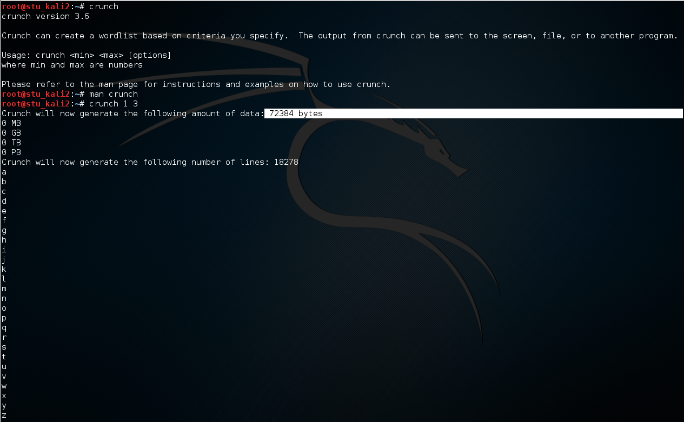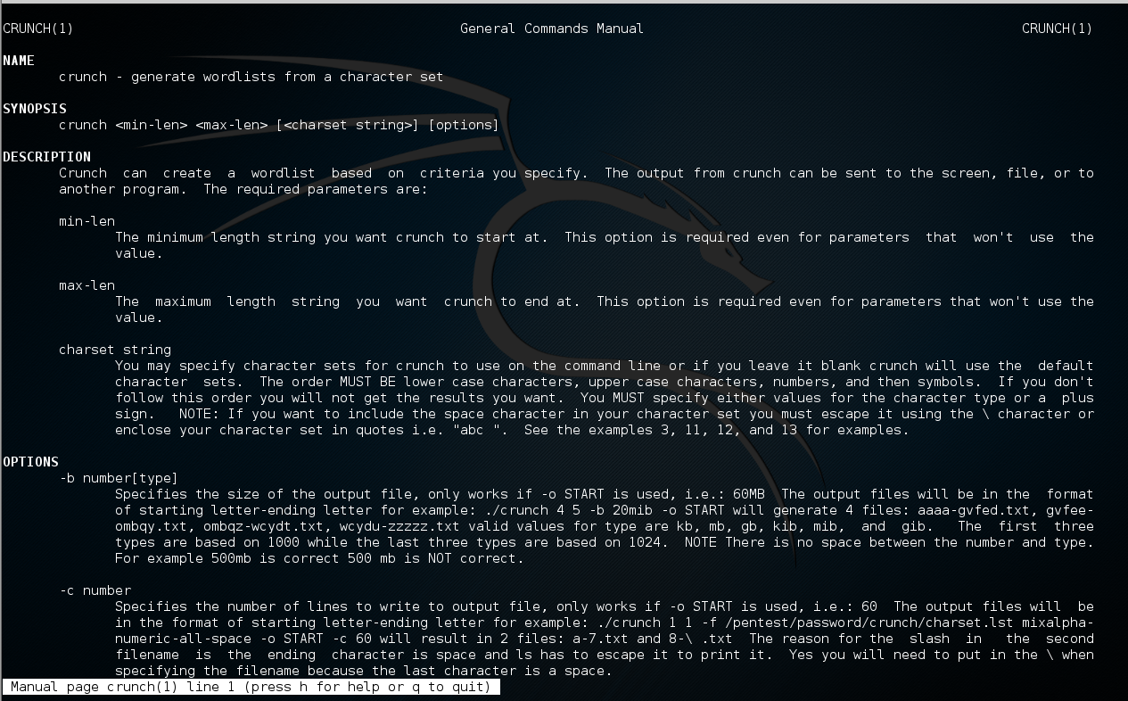

One of the option in Crunch utility is -o which generate the wordlist in a sperate file instead of showing in a terminal. As an example we tried the following command to generate the wordlist in a separate file named Weissman: **crunch 1 3 -o Weissman.txt** then we type **leadfpad Weissman.txt** to show the saved wordlist in that file.

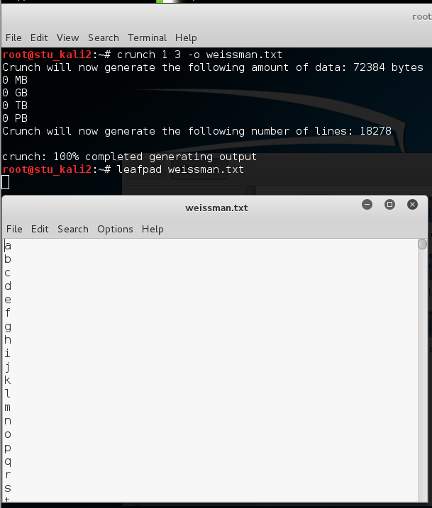

We tried the following commands while keeping an eye on the amount of data generated and number of lines which increase as the length of the passwords become longer and more complex.

**Crunch 3 6** where 3 is the minimum character and 6 is the maximum character length

**Crunch 8 12**

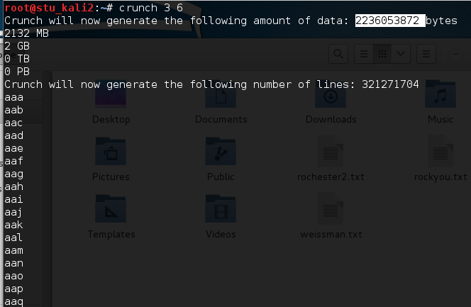

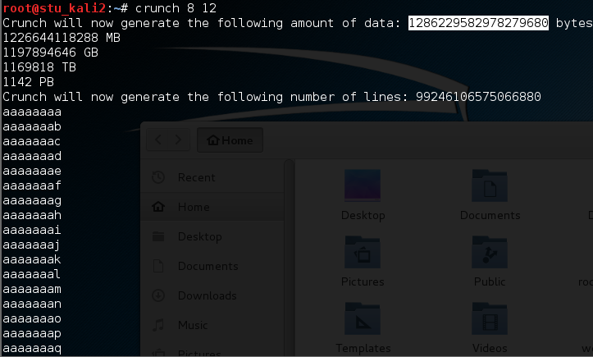

**Crunch 1 3 abc** in this case the generated wordlist will contain only abc letters.

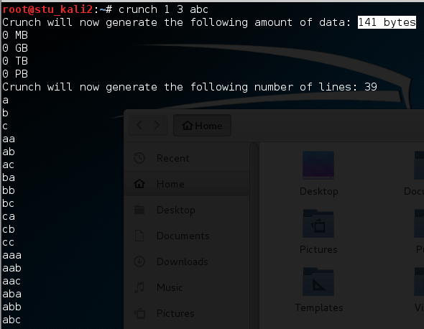

**Crunch 5 8 RITx!** In this case the wordlist generated only contain ritx letters and ! special character .

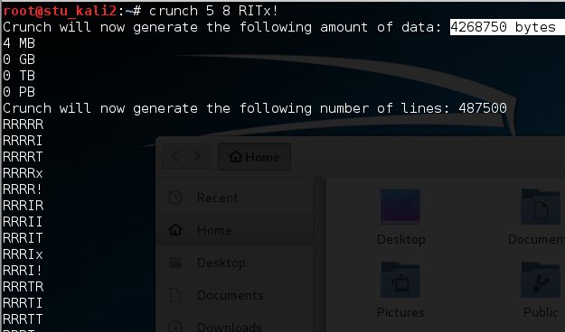

**Cat /usr/share/rainbowcrack/charset.txt** is a command show us different choices of character sets that we can use to generate a wordlist.

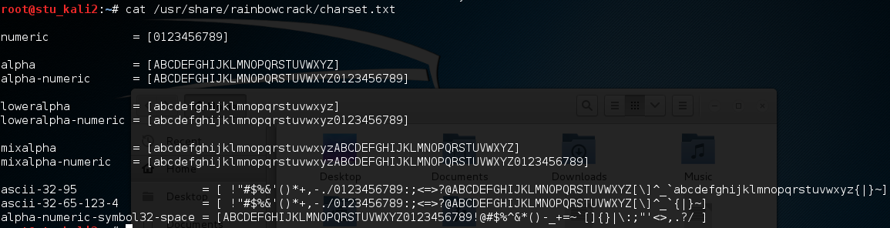

By using previous character set, we can specify a wordlist that is 8 characters long contains small and capital letters and numbers.

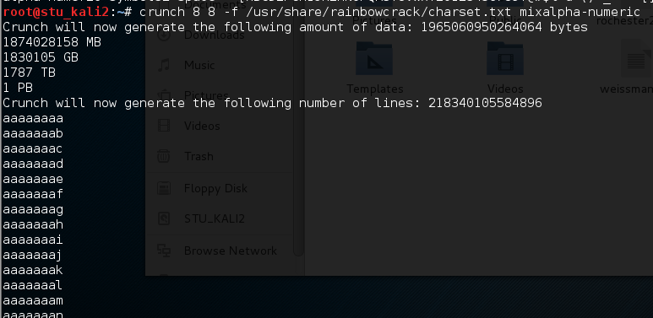

Also, we can specify a wordlist that have 8 character long and contains: letter, number special character and space.

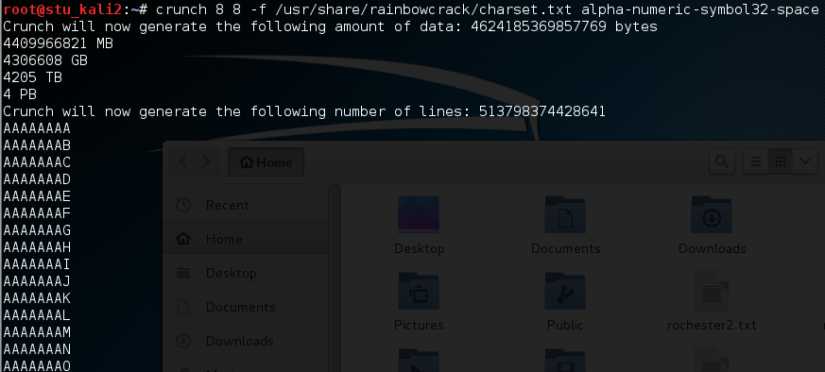

We can use this feature by narrow our wordlist to a given information: for example: based on social media information , we know that we have an employee, bob smith, who’s birthday on 15/4. We use this information by specifying his birthday as a static character and let the wordlist try the rest of the characters using the symbol @.

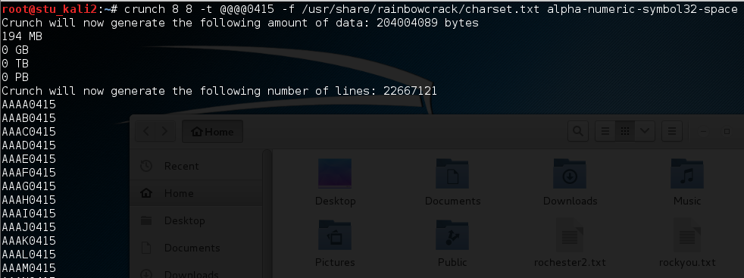

Another example of making use of the crunch utility specification features is that we try to crack a password by limiting the wordlist to a given information which is a spouse name: alice.

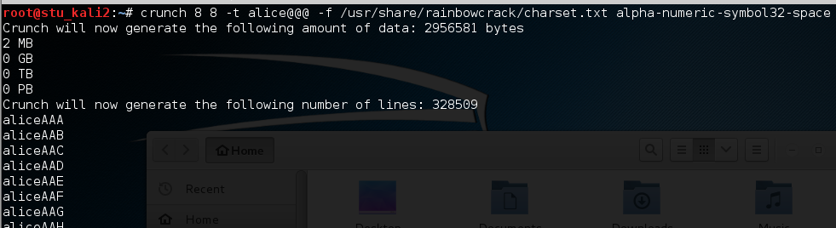

Another useful characteristic in crunch utility is deleting repetitive characters by using -p option. In this case we have to specify the minimum and the maximum character even though it won be implement.

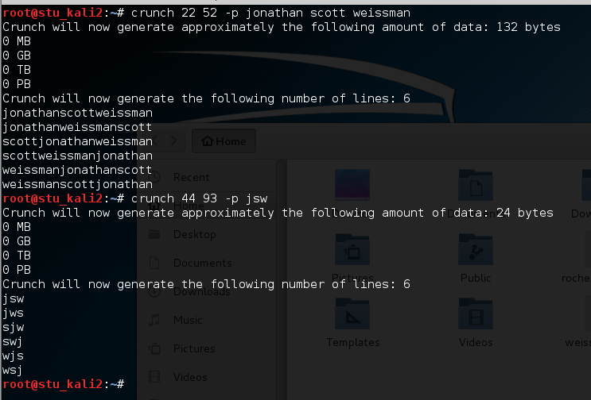

John the ripper:

John the ripper is one efficient way to crack passwords. By typing john we can see the basic usage and for more option we can go to john manual page by typing man john.

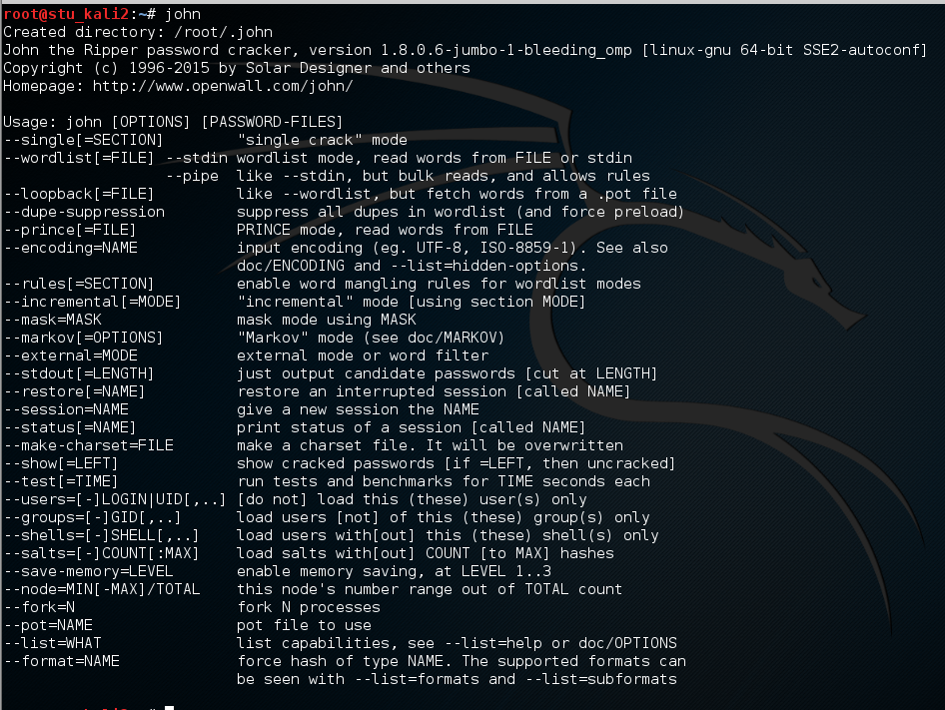

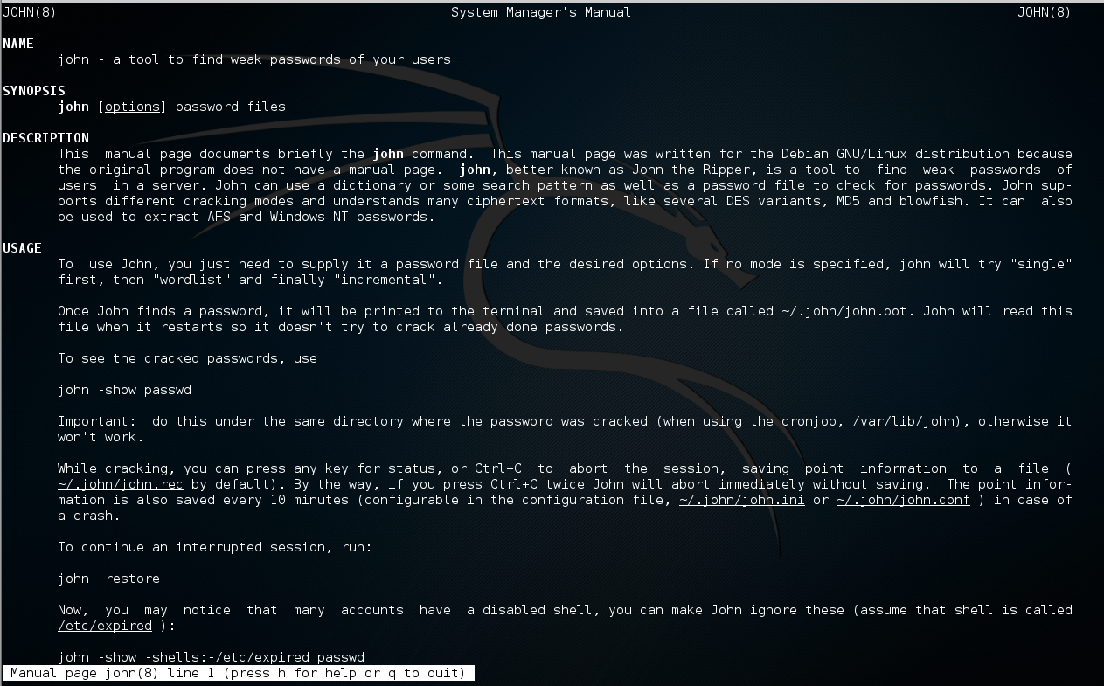

We can see the various encryption scheme that john support and the amount of time needed to crack each one of them by typing john -test.

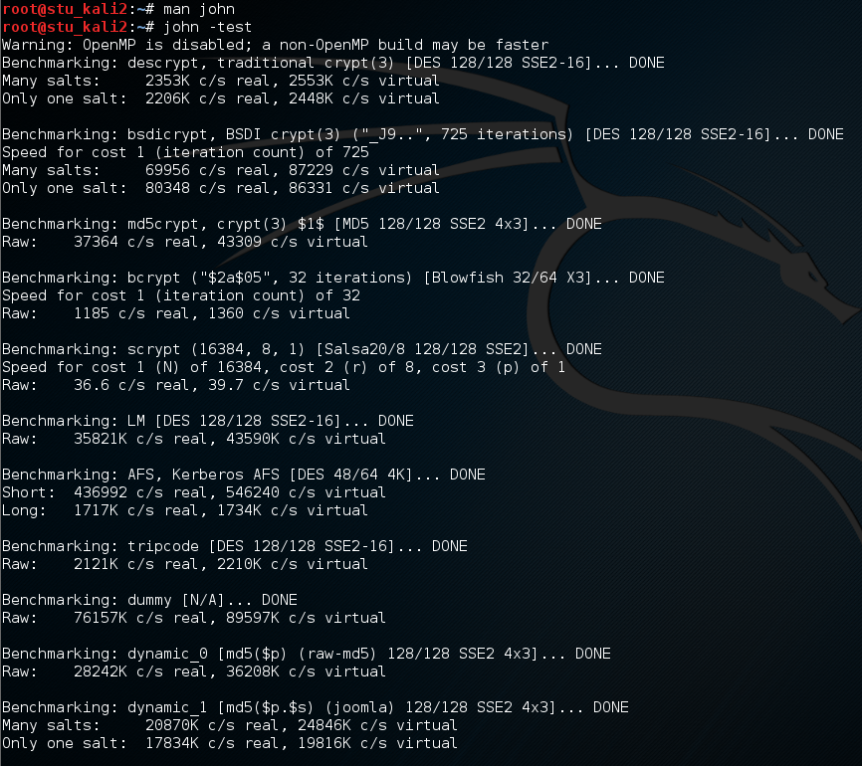

Then we added 5 users with given passwords for each one.

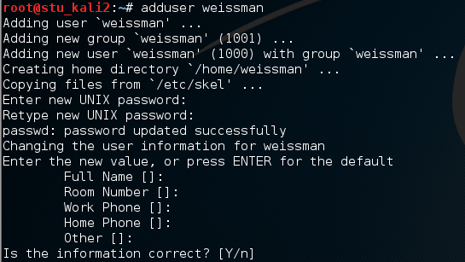

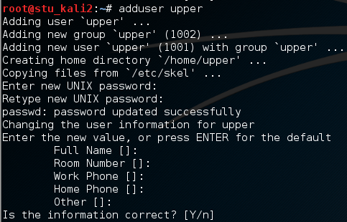

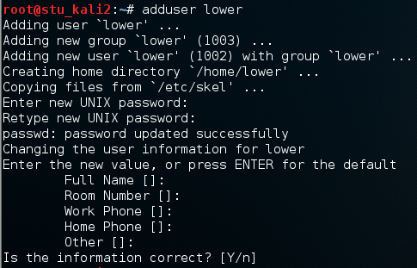

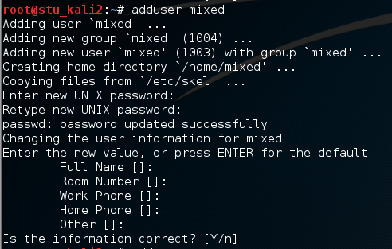

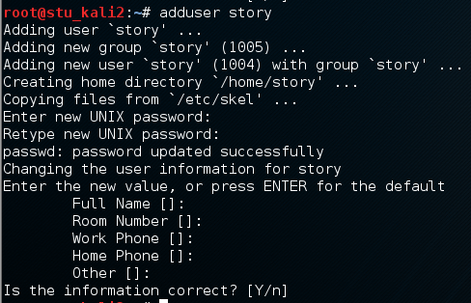

In order for john the ripper to perform we have to provide file of user name combined with a file for hashed passwords. In Linux, the usernames information contain in /etc/passwd/ file and hashed passwords in /etc/shadow file. we can combine both file in one file by using the unshadow command and fitch it to john to crack it. In our case we added both files which contain 5 users that we added and it combined to a file name Rochester.txt. To verify the combination, we can see the content of Rochester.txt file which contain the user information along with hased passwords

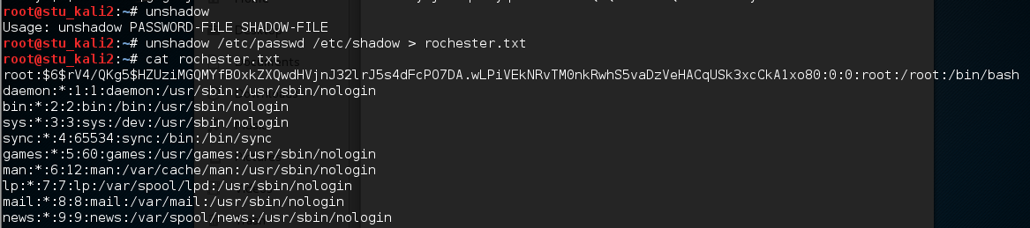



Then we crack the passwords on Rochester.txt file by using the list provided within john the ripper. Then we can see the passwords have been cracked. Also, we can see all the cracked password in the file along with its corresponded username by the following command: john –show Rochester.txt

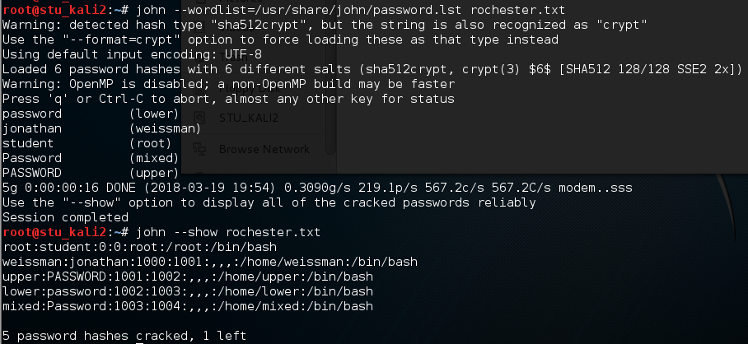

We create another user bob, and we combine the users information file with the hashed passwords to a new updated file : Rochester2.txt. This time we can crack the file without the wordlist. And we were able to see all the cracked passwords

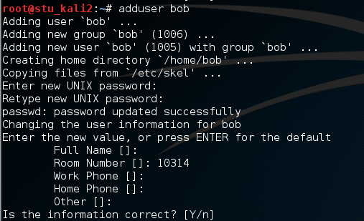

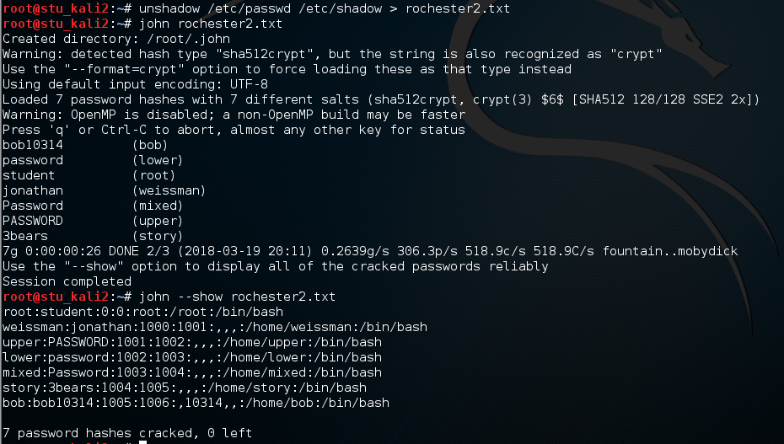

We also use john the ripper with a wordlist file that is generated by crunch called crunchfile.txt

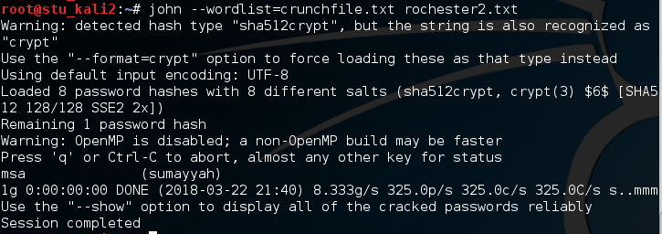

Rockyou:

Along with John the ripper, we can use rockyou as additional wordlist to crack passwords more easily. Rockyou.text contains millions of word which increase the capability of john the ripper in case the list in john wasn’t able to crack the password. After copying rockyou.txt to our directory, we compare between the size of rockyou.txt and john file, and we find out that john is much smaller than rochyou.txt. Furthermore, we compare the wordlists contained in each file, and as the figures presents below, we can see rockyou.txt file has way more wordlists than john file. Rockyou is an effective way to crack easy passwords.

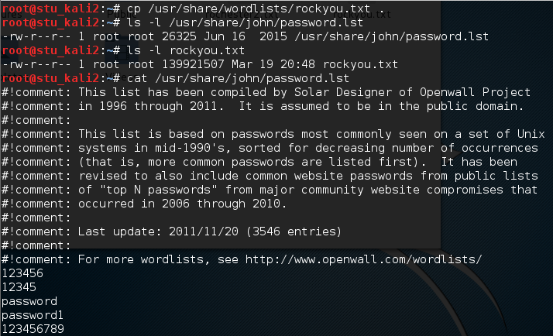

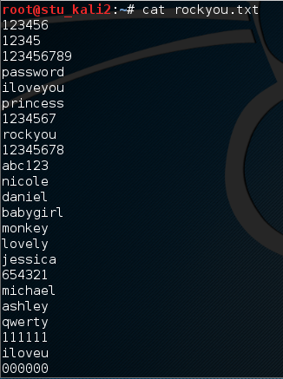

We added more users with easy, medium and hard passwords then we try to crack it using john the ripper with the rockyroad wordlist.

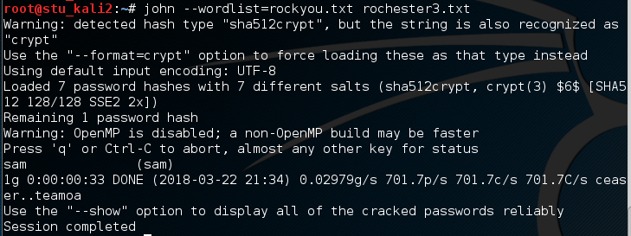

Ophcrack:

Ophcrack uses rainbow table to crack passwords. After successfully downloads ophcrack, we follow theses steps to crack passwords. It is for cracking windows password. We downloaded two tables: vista and vista proba free. In the main interface, we have a user account and its hashed password. After clicking crack, we can see that the password has been cracked by rainbow tables. In this particular example we see the crcked password is “student.”

.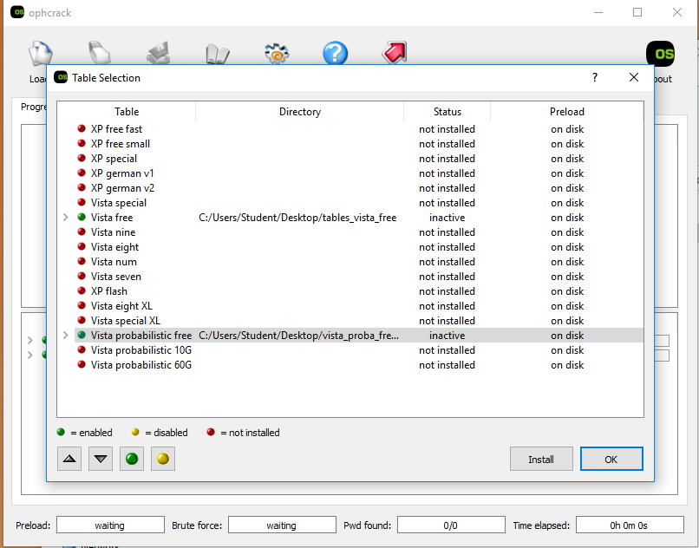

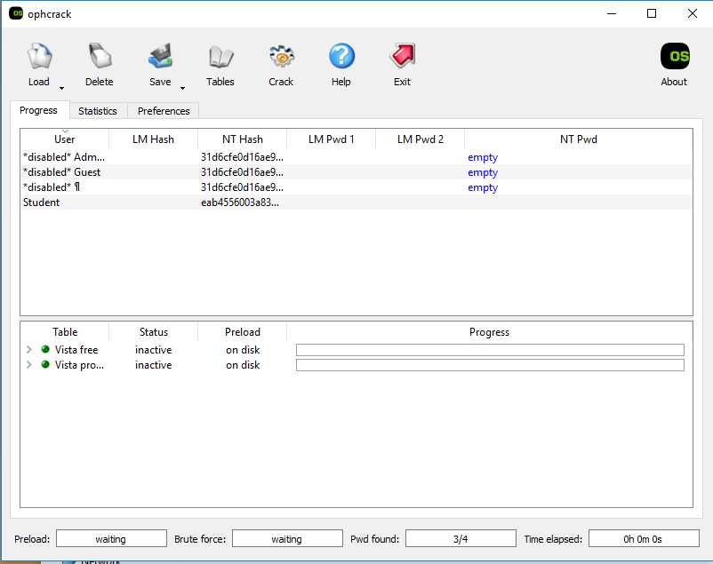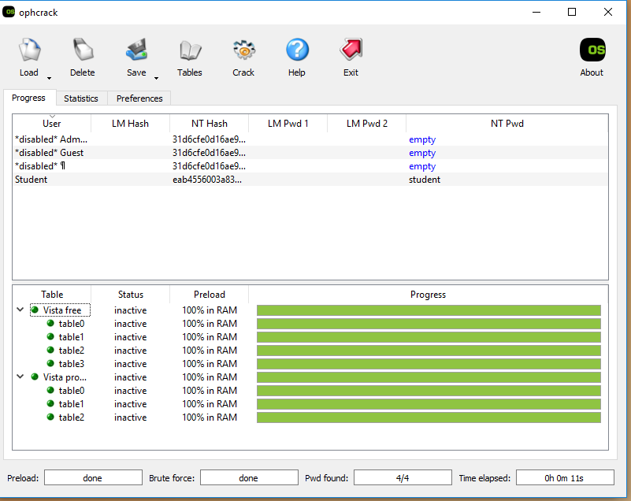

Conclusion:

To summarize, in this report, we used two utility to help us crack passwords which is john the ripper and ophcrack using rainbow table attack. Also, we have tried two mechanism to generate wordlists that are used as potential passwords. As we tried different commands, we become familiar with various options that each utility offers.

Reference:

[1] Parker, P., Lost, D., C., Sakib, S., Wozniacki, B., Ali, S., . . . Muteeb, A. (2014, August 12). Hack Like a Pro: How to Crack Passwords, Part 4 (Creating a Custom Wordlist with Crunch). Retrieved March 22, 2018, from <https://null-byte.wonderhowto.com/how-to/hack-like-pro-crack-passwords-part-4-creating-custom-wordlist-with-crunch-0156817/>

[2] Slangen, S. (2009, July 17). Ophcrack – A Password Hack Tool to Crack Almost Any Windows Password. Retrieved March 22, 2018, from <https://www.makeuseof.com/tag/hack-windows-passwords-with-ophcrack/>

[3]Leyden, J. (n.d.). RockYou hack reveals easy-to-crack passwords. Retrieved March 22, 2018, from <https://www.theregister.co.uk/2010/01/21/lame_passwords_exposed_by_rockyou_hack/>

[4] John the Ripper. (2014, February 18). Retrieved March 22, 2018, from <https://tools.kali.org/password-attacks/john>